Assignment 1.1: Set Up Snort
Raymond Olmos
University of San Diego
CYBR-512-02B Incident Detection and Handling
Professor Steven Richard
October 25, 2026

Lab environment:
The lab environment consisted of Kali Linux as the designated attacker, Metasploitable 2 as the designated victim, and Ubuntu running Snort as the IDS. All three VMs were configured to use the VirtualBox NAT Network named SandBox1.
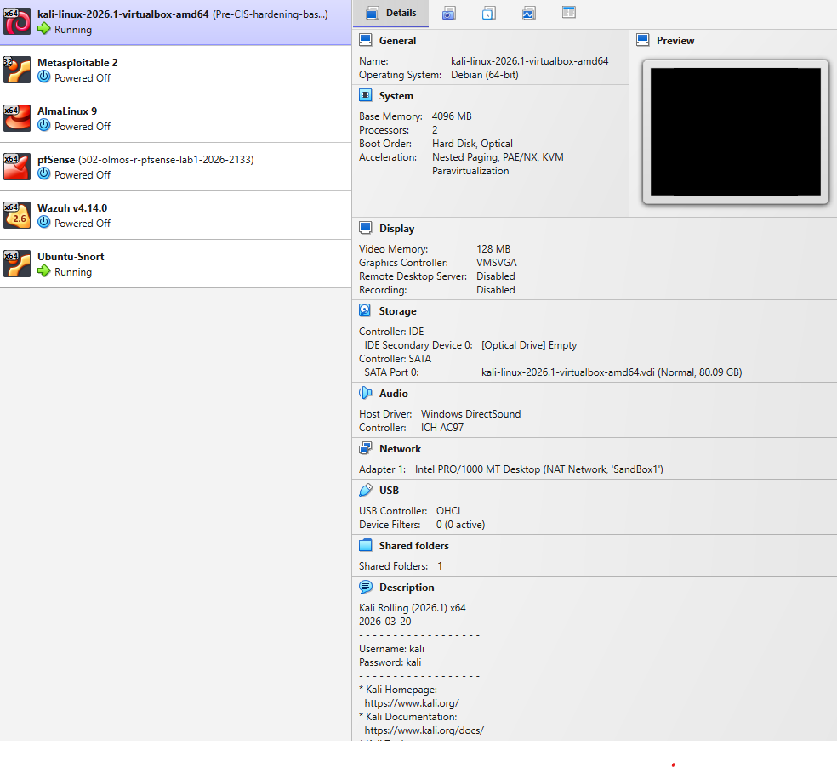
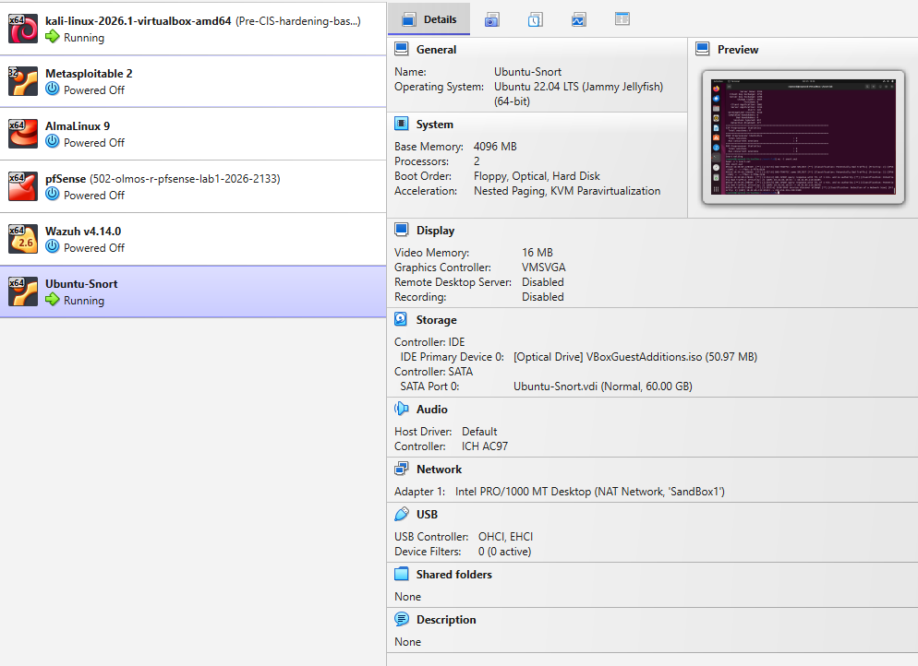
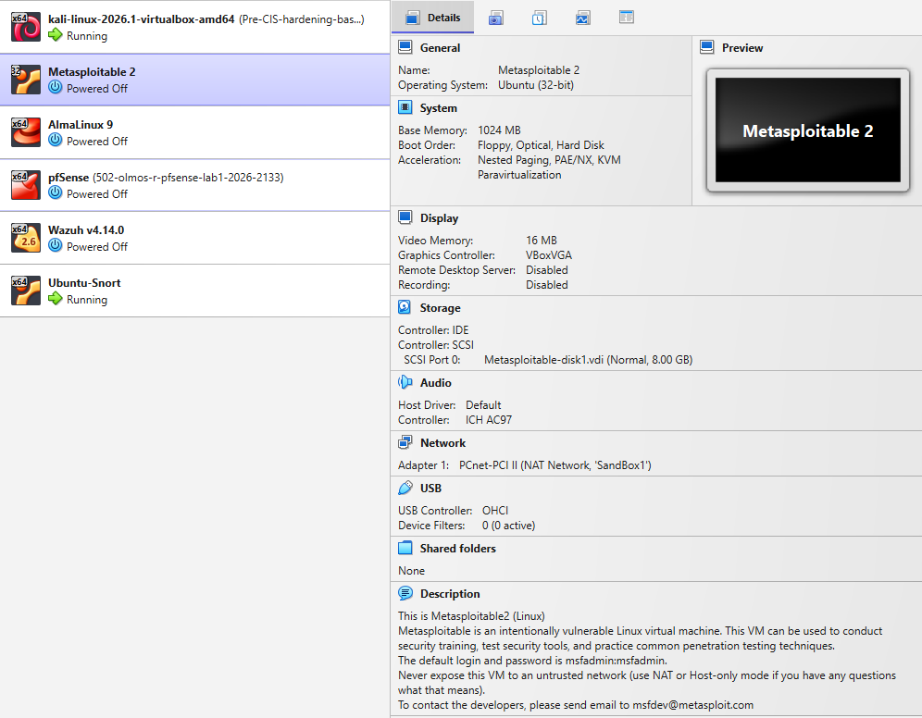
Figure 1. VirtualBox configuration showing VM’s attached to the SandBox1 NAT Network.
Section 1: Network Interface and IP Address
I ran ip addr and ip route on the Ubuntu Snort VM to identify its network interface, IPv4 address, and default gateway. The active interface was enp0s3, with IPv4 address 10.0.2.5/24 on the 10.0.2.0/24 subnet. The default route used gateway 10.0.2.1 through enp0s3, confirming that enp0s3 was the default network interface.
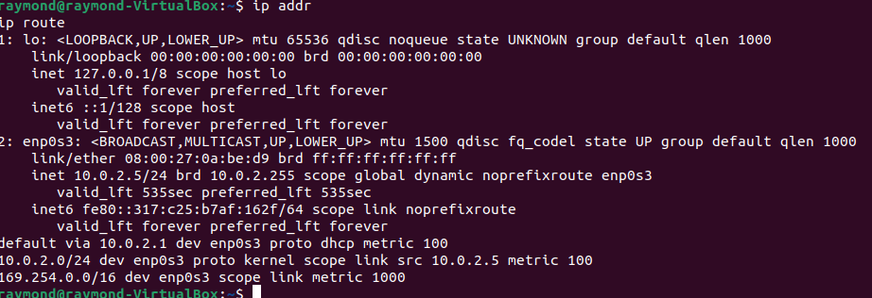
Figure 2. Snort VM network configuration showing interface enp0s3, IPv4 address 10.0.2.5/24, and default gateway 10.0.2.1.
Section 2: Snort Configuration Validation
I tested the Snort configuration by running sudo snort -T -c /etc/snort/snort.conf. Snort version 2.9.15.1 initialized and displayed “Snort successfully validated the configuration!” This confirmed that the configuration passed Snort’s validation test. Snort then exited test mode.
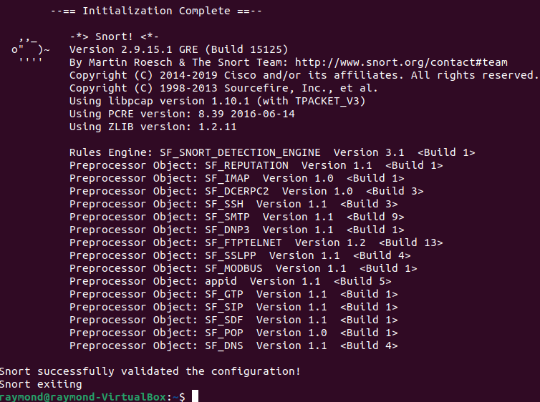
Figure 3. Successful validation of the Snort configuration.
Section 3: Snort Sniffer-Mode Test
I enabled promiscuous mode on the Snort VM’s enp0s3 interface and started Snort using sudo snort -v -i enp0s3 -c /etc/snort/snort.conf. Snort displayed captured TCP packet headers, including source and destination addresses, ports, timestamps, and packet lengths. The observed traffic included packets exchanged between 10.0.2.15 and 104.18.37.251, demonstrating that Snort was capturing network packets.
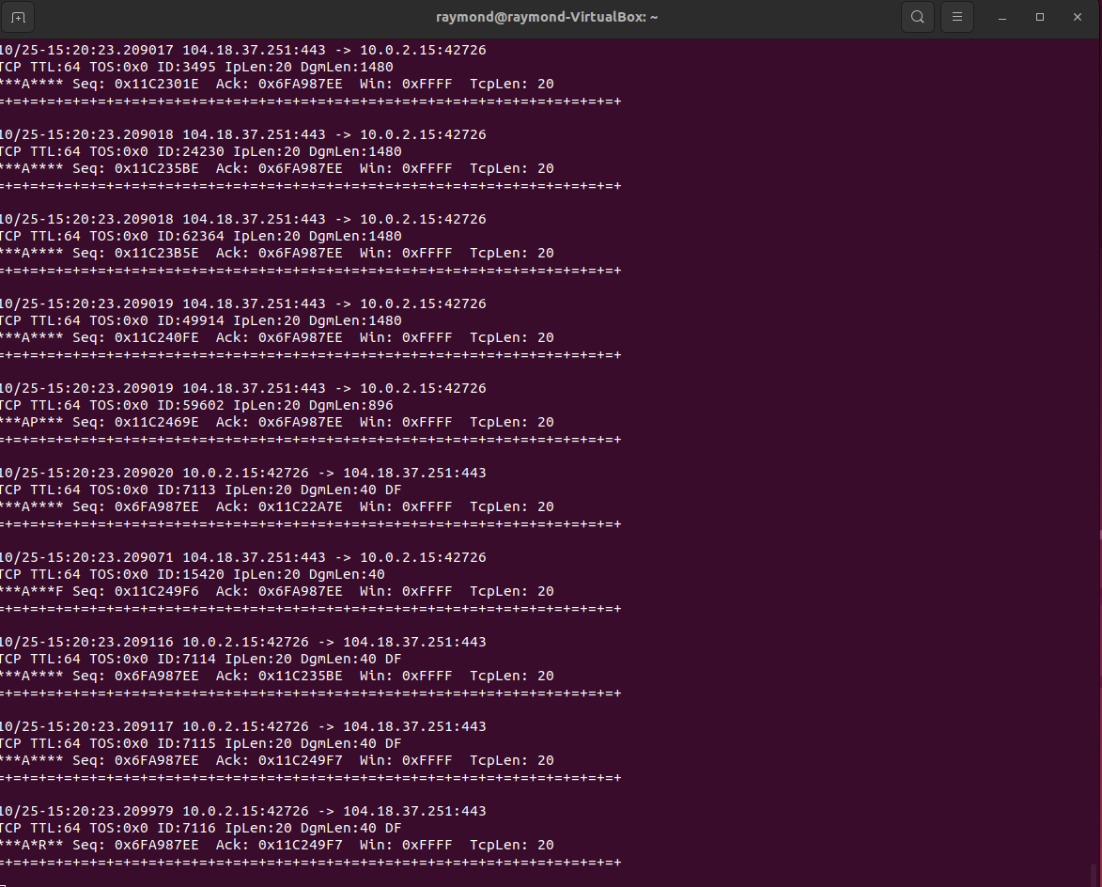
Figure 4. Snort sniffer-mode output displaying captured TCP network traffic.
Section 4: Custom Rule Creation and Testing
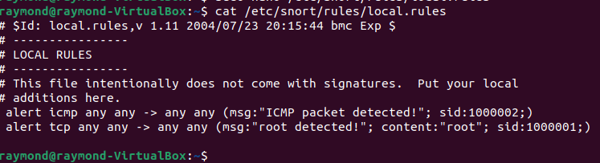
Figure 5. Custom Snort rules configured to detect ICMP packets and TCP content containing the string “root”.
I tested the custom ICMP rule by running ping -c 4 10.0.2.1 from the Snort VM while Snort was running in console-alert mode. All four ping requests received replies, with 0% packet loss. Snort generated eight alerts displaying “ICMP packet detected!” with SID 1000002, corresponding to four outgoing requests and four incoming replies. This demonstrated that the custom rule detected ICMP traffic in both directions.
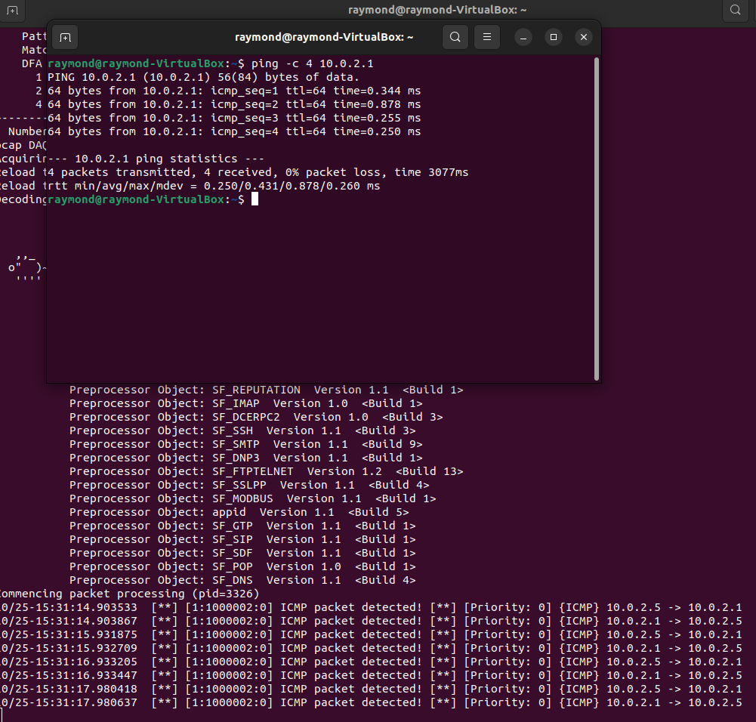
Figure 6. Successful ICMP rule test showing four ping requests and eight corresponding Snort alerts.
I tested the custom TCP rule configured to detect the string “root.” The original test URL returned a domain-parking page rather than the content expected by the assignment walkthrough. To provide a known plaintext test string, I added ?root to the HTTP request URL. After restarting Snort with checksum verification disabled using -k none, I repeated the request. Snort generated a “root detected!” alert with SID 1000001 for outgoing TCP traffic from 10.0.2.5:54384 to 103.224.182.211:80. This demonstrated that the unchanged custom rule detected the test string in the HTTP request.
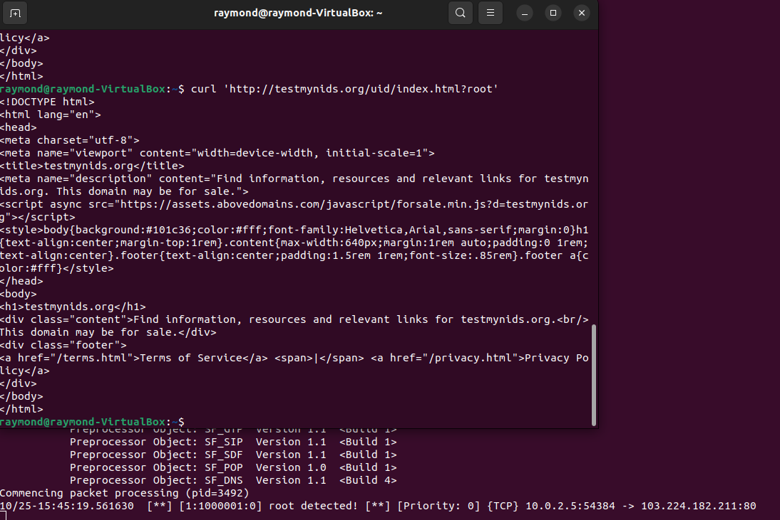
Figure 7. Successful TCP content-rule test showing the “root detected!” alert with SID 1000001.
Section 5: PCAP Analysis and Alert Count
I downloaded and extracted case001.pcap and disabled the two temporary custom rules before analysis. I then processed the capture using sudo snort -A console -c /etc/snort/snort.conf -r case001.pcap > snort.out. After processing completed, I ran wc -l snort.out, which reported 302 lines of alert output. I inspected the first five alerts using head -n 5 snort.out. These included “BAD-TRAFFIC same SRC/DST,” “DNS SPOOF query response with TTL of 1 min. and no authority,” and “SCAN UPnP service discover attempt.” The total matched the instructor’s example of 302 alerts.
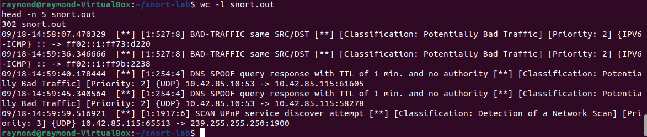
Figure 8. PCAP analysis results showing 302 alert-output lines and the first five Snort alerts.

References
Snort. (2019). Snort - Network Intrusion Detection & Prevention System. Snort.Org; Snort. https://www.snort.org/

